Motif Finding

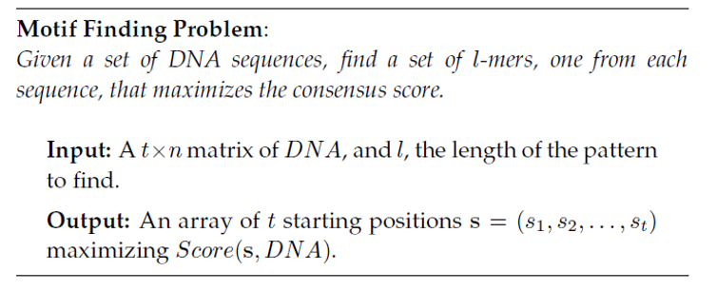

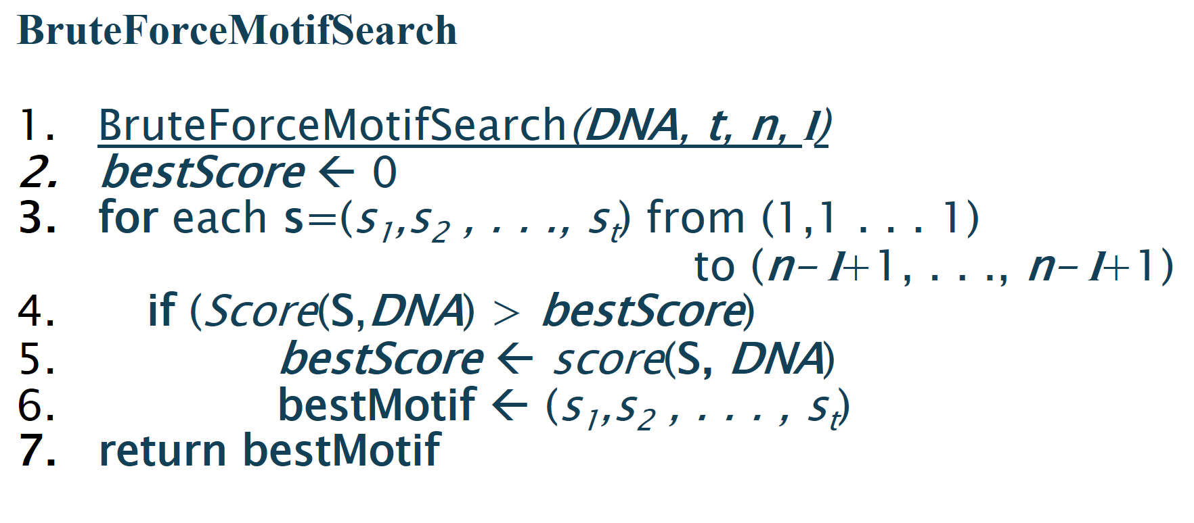

## **Example:**

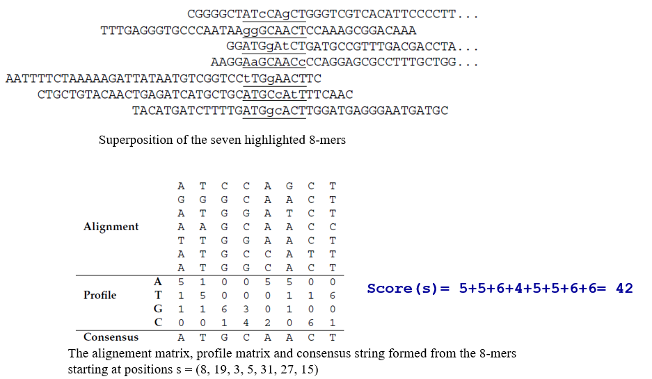

## **Task:**

Write a program that computes the **score** function in the motif finding. Bonus, implement the whole algorithm of motif finding.